**PIZZA SALES SQL QUERIES CHARTS**

**CHARTS**

1. **Daily trend for total order**

select DATENAME(DW, order_date) as order_day, COUNT(DISTINCT order_id) as Total_Orders from pizza_sales

GROUP BY DATENAME(Dw, order_date)

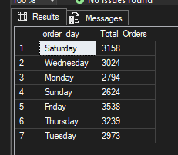

1. **Monthly trend for total order**

select DATENAME(MONTH, order_date) as month_Name, COUNT(DISTINCT order_id) as Total_Order from pizza_sales

GROUP BY DATENAME(MONTH, order_date)

ORDER BY Total_Order desc

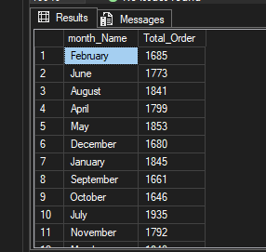

1. **Percentage of sales by pizza category**

select pizza_category,SUM(Total_Price) as Total_Sales, SUM(Total_Price) * 100 / (select SUM(Total_Price) from pizza_sales WHERE MONTH(order_date) = 8) as PCT from pizza_sales

WHERE MONTH(order_date) = 8

GROUP BY pizza_category

**Note:** WHERE MONTH(order_date) = 8, normal use to give the percentage of a specific month

1. **Percentage of sales by pizza price**

select pizza_size,SUM(Total_Price) as Total_Sales,CAST( SUM(Total_Price) * 100 / (select SUM(Total_Price) from pizza_sales WHERE MONTH(order_date) = 8

) as decimal (10,2)) as PCT from pizza_sales

WHERE MONTH(order_date) = 8

GROUP BY pizza_size

ORDER BY PCT desc

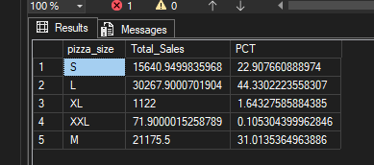

1. Top 5 pizza sellers

select TOP 5 pizza_name, SUM(Total_Price) as Total_Revenue from pizza_sales

GROUP BY pizza_name

ORDER BY Total_Revenue desc/ASC

